Practical 9:-

- Implement a file copy utility using low-level Linux file I/O system calls (open, read, write, lseek, close). Compare its performance with standard library functions (fopen, fread, fwrite).

Develop a program that redirects standard input and output using file descriptors and dup2(). Demonstrate how shells implement I/O redirection.

Code :-

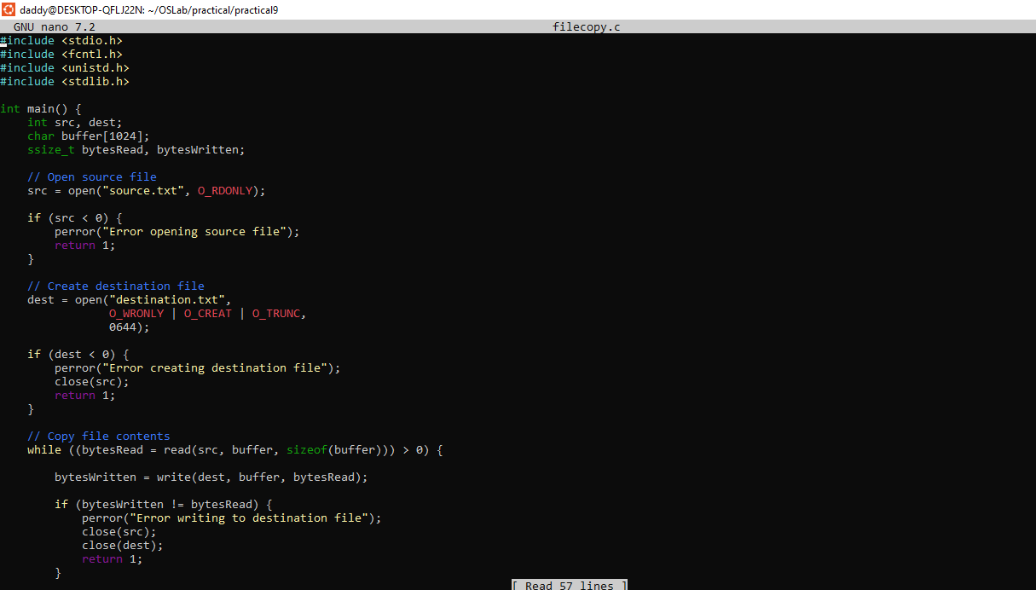

Output :-
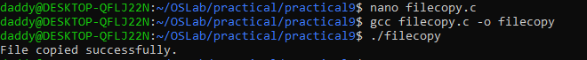

Program 2

Code:-
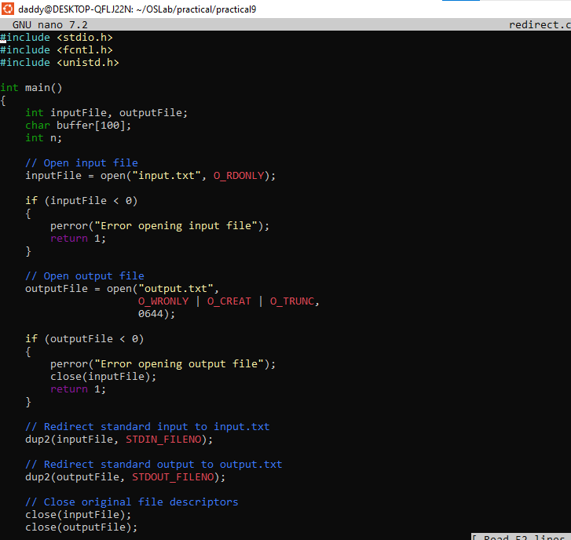

Output:-

